**DAILY ONLINE ACTIVITIES SUMMARY**

|  |  |  |  |  |  |  |  |  |
| --- | --- | --- | --- | --- | --- | --- | --- | --- |
| **Date:** | **15-07-2020** | | | | | **Name:** | **Anix Jugal D’Cunha** | |
| **Sem & Sec** | **8 sem , A sec** | | | | | **USN:** | **4AL16CS013** | |
| **Online Test Summary** | | | | | | | | |
| **Subject** | | **Not Conducted** | | | | | | |
| **Max. Marks** | | **--** | | **Score** | | | **--** | |
| **Certification Course Summary** | | | | | | | | |
| **Course** | **Complete PHP OOP Concepts for Absolute Beginners + Projects** | | | | | | | |
| **Certificate Provider** | | | **Udemy** | | **Duration** | | | 10.5 hours |
| **Coding Challenges** | | | | | | | | |
| **Problem Statement:** Validating a Phone Number Format String | Java Programs. | | | | | | | | |
| **Status: Competed** | | | | | | | | |
| **Uploaded the report in Github** | | | | | **yes** | | | |
| **If yes Repository name** | | | | | **alvas-education-foundation/dcunhaanixjugal** | | | |
| **Uploaded the report in slack** | | | | | **yes** | | | |

Online Test Details: (Attach the snapshot and briefly write the report for the same)

**Not Conducted**

Certification Course Details: (Attach the snapshot and briefly write the report for the same)

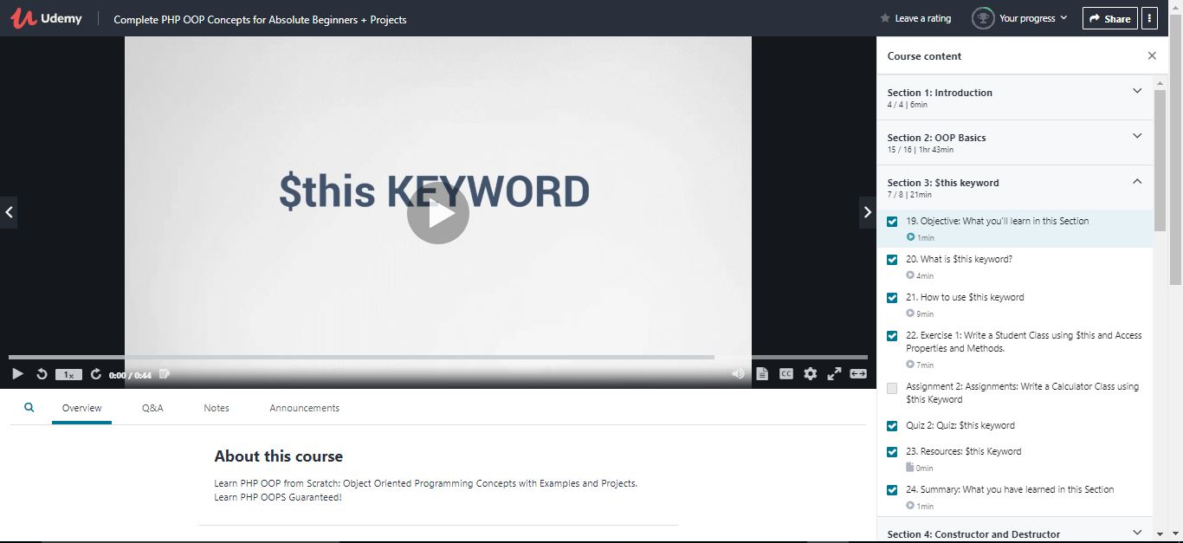

Coding Challenges Details: (Attach the snapshot and briefly write the report for the same)

## Program-> Validating a Phone Number Format String | Java Programs.

|  |
| --- |
|  |

**class PhoneNumberFormatting**

**{**

**public static void main(String arg[])**

**{**

**long n=10;**

**int a[]=new int[10];**

**Scanner sc=new Scanner(System.in);**

**System.out.println("Enter a digits of phone number");**

**for(int i=0;i<n;i++)**

**{**

**a[i]=sc.nextInt();**

**if(a[i]<0 || a[i]>9)**

**{**

**System.out.print("wrong input");**

**return;**

**}**

**System.out.println("");**

**}**

**System.out.print("phone number format--->");**

**for(int i=0;i<n;i++)**

**{**

**if(i==0)**

**System.out.print("\"(");**

**if(i==3)**

**System.out.print(") ");**

**if(i==6)**

**System.out.print("-");**

**System.out.print(a[i]);**

**if(i==9)**

**}**

**}**

**}**

**output:Enter a digits of phone number**

**1 2 3 4 5 6 7 8 9 0**

**phone number format--->"(123) 456-7890"**